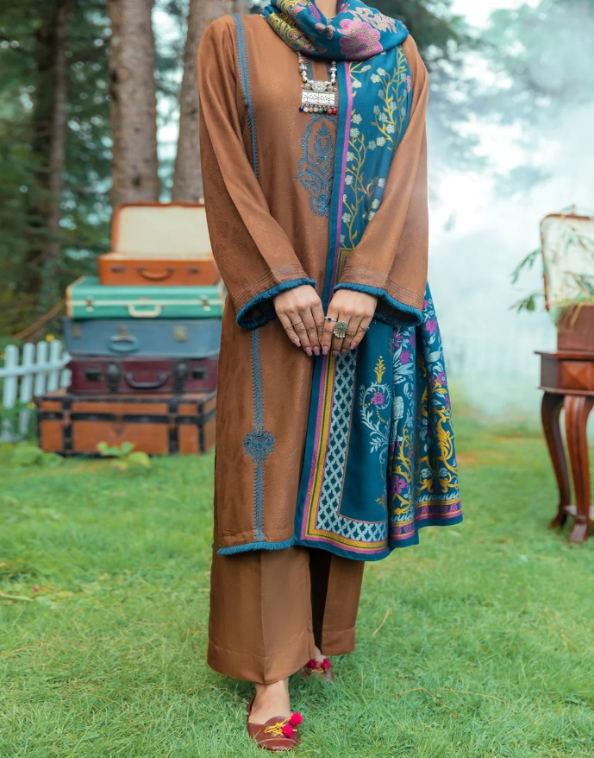

# BEIGE VISCOSE TWILL 3 PIECE STITCHED - AWP-3PS-539

Rs.8,887.50

**ADDITIONAL INFO**

|  |  |
| --- | --- |
| **Color** | Beige |
| **Pieces** | 3 Pieces |
| **Fit Type** | — |
| **Fabric** | Twill Viscose, |
| **Season** | Winter Collection |
| **Disclaimer** | Due to the photographic lighting & different screen calibrations, the colors of the original product may slightly vary from the picture. |